**ENGLISH FOR SD students – English Practice |Lesson 1**

**A. How to say hello and introduce yourself**

1. Rosa has moved to Chicago and needs an International Student Card to get some discounts in the US. **She is talking to the ISIC counter attendant to get a card. Write the questions for Rosa’s answers.**

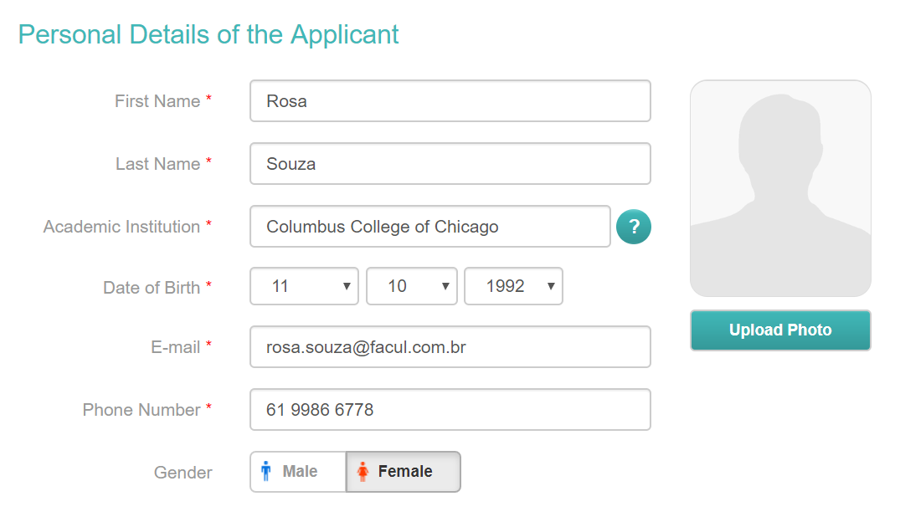



*Attendant: Hello, Rosa. I have a few questions for you.*

Rosa: Ok, I have all my documents here with me.

*Attendant:* _________________________________________________________

Rosa: My last name is Souza.

*Attendant:* _________________________________________________________

Rosa: I am from Brazil.

*Attendant*: _________________________________________________________

Rosa: My e-mail address is rosa.souza@facul.com.br

*Attendant*: _________________________________________________________

Rosa: It’s 61 9986 6778

*Attendant:* _________________________________________________________

Rosa: Yes, I am. I’m a student at Columbus College of Chicago.

*Attendant. Thank you very much. Here is your card.*

Rosa: Thanks.

2. Complete the form with your details. **Then, practice the dialog from exercise 1 with a partner.**

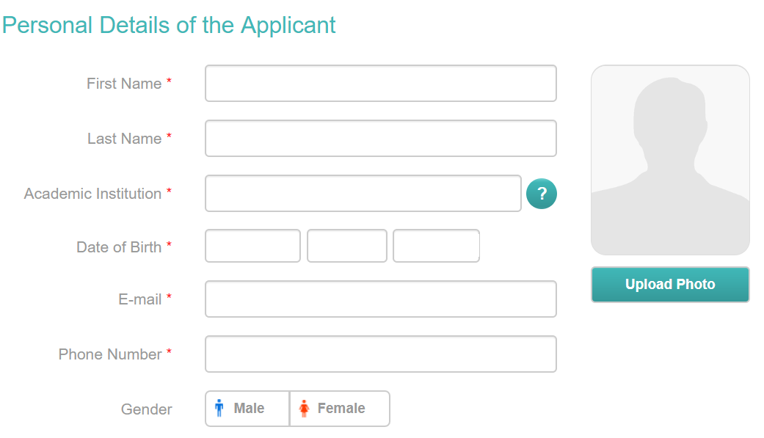

**3. What do you say in each of the following situations? Use greetings and goodbyes you learned in lesson 1.**

a. a friend says HI =

b. you see your teacher in the morning =

c. you say bye to a friend after a dinner party =

d. you meet a classmate for the first time =

**4. Now, imagine you are meeting your classmate for the first time:**

a. Greet the person accordingly;

b. Introduce yourself;

c. Ask his/her name;

d. Ask him/her to spell his/her first, second, middle, or last name;

e. Ask him/her if he/she is from Pelotas or another city;

f. Exchange e-mail addresses.

**5. Introduce the people below writing full sentences.** Mention their names, occupations, nationalities, the language they speak and any other information you find relevant.



Mark Zuckerberg

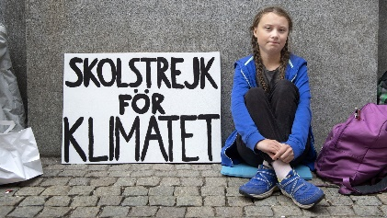

Greta Thunberg

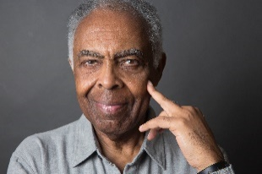

Gilberto Gil

6. You are talking to a classmate about the celebrities above. **Make 5 questions about them (Mark, Greta and Gil).** Then work with a classmate as ask the questions you’ve made.

……………………………………………………………………………………………………………………………………………………………………………………………………………………………………………………………………………………………………………………………………………………………………………………………………………………………………………………………………………………………………………………………………………………………………………………………………………………………………………………………………….....

**7. Fill in the blanks with the verb TO BE [am/is/are]**

a. Lionel Messi ……………. from Argentina.

b. Where ……. Messi and Pope Francis from?

They ……… from Argentina.

c. This ……… my teacher. ……….. name is Adão. He ……. from Canoas.

d. ……….. you an actor?

e. I ……… from Brazil.

**8.** Countries, Nationalities, and Languages. Read the sentences below. **Talk to your classmate and correct them.**

a. Pope Francisco is French **Pope Francisco isn’t French. He’s Argentinian**.

b. Flamenco dance is popular in the U.K.

c. English is the most spoken language in the world.

d. Canada, Mexico and the U.S. are South American countries.

e. The language in Brazil is Brazilian.

f. Greta Thunberg is from Russia. She is a ballerina.

9. Você irá assitir a um video da *youtuber* e professora de inglês gaúcha, Carina Fragozo. O título do vídeo é “o que os youtubers gringos sabem sobre o Brasil”. **Complete the chart according to what you listen in the video.**

|  |  |  |  |
| --- | --- | --- | --- |
|  | **Country/Nationality** | **Youtube channel** | **What comes to your mind when you think of Brazil?** |
| Chris Ramsey |  |  |  |
| Gil |  |  |  |
| Not mentioned |  | Food and travel |  |
| Sierra Schultzzie |  |  |  |
| Not mentioned |  |  |  |